**Bahria University, Lahore Campus**

Department of Computer Science

Lab Journal 09

**(Spring 2023)**

|  |  |  |
| --- | --- | --- |
| Course: | **Data Structures and Algorithm - Lab** | Date: _______________ |
| Course Code: | CSL-221 | Max Marks: 10 |
| Faculty’s Name: | Fatima Zulfiqar |  |

Name: _____________________ Enroll No: ___________________ Class: ______________

Objective(s):

Upon completion of this lab session, learners will be able to:

* Implement binary tree data structure
* Implement tree traversal i.e. in-order, pre-order and post-order
* Search for a particular element in a binary tree.

## Lab Tasks:

**Task 1**

Write a program to implement a given binary tree data structure

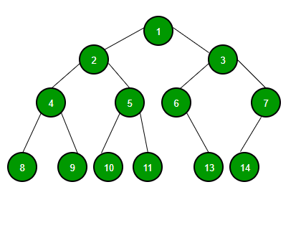

**Task 2**

Using tree obtained in **Task 1,** implement a function to perform following tree traversal.

* In-order traversal
* Pre-order traversal
* Post-order traversal

**Task 3**

Write a function to search for a specific element from the binary tree generated in **Task 1.** If an element is present in a tree simply display a message **“*an element is present in a binary tree*”** otherwise display **“*an element is not present in a binary tree*”.**

**Lab Grading Sheet :**

|  |  |  |  |
| --- | --- | --- | --- |
| **Task** | **Max Marks** | **Obtained Marks** | **Comments(*if any*)** |
| 1. | 2 |  |  |
| 2. | 6 |  |  |
| 3 | 2 |  |  |
| **Total** | **10** |  | **Signature** |

**Note : Attempt all tasks and get them checked by your Lab Instructor. Also for each task, attach a screenshot of the output.**